The Cube – An Educational Tool

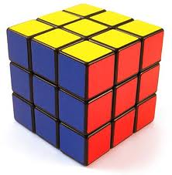

- The “Cube” Method

The “Cube“ is a technique used for developing multidimensional understanding of concepts. The teacher asks students to write on each six-sided cube, using each to explain one of the concepts in the table before:

CONCEPTS | TASK
-Description | “What is it like?”
-Comparison | “What is it similar to or different from?”
-Association | “What does it make you think of?”
-Analyses | “How is it made?” “What is it composed of?” “What are its features?”
-Application | “What can you do with it?” “How is it used?”
-Argumentation | “Bring arguments for and against”

Students can create cubes individually, in pairs or in small groups, and their responses can be entered in one of the boxes of a precut sheet of paper, which, when folded, creates a cube.

- The Cube
WORKSHEET
Lesson: Going Underground
TEXTBOOK: MISSION 2
FORM : 10th
Materials: a cube; the six-faces are different coloured
Students are divided into 6 groups of 3 or 4, according to the complexity of the task. Each group has a colour and they have to accomplish the task written on the coloured face of the cube.
Describe
Describe an underground house.

Compare
Compare the two types of dwellings.

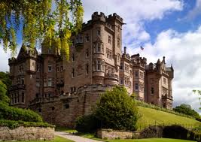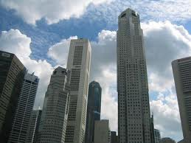

Associate
Associate the words with the right definition.

this describes city places mud-stone
this describes country places shaft
the part of the earth which is underground urban
easily damaged rural
a mixture of clay and rock fragile vertical passage subterranean

Analyze the advantages and disadvantages of living underground.
Analyze
Apply

Use the information from the lesson and offer solutions to a better underground living.
Argue
“Would you like to live in the past or in the future?” Bring arguments

in favour of your choice.

The cube
  - Describe Underground houses are less noisy, less expensive to heat and far less destructive to our fragile environment. All that marks the position of an underground house is a door in the grass.
  - Compare The first picture is of a castle, while the second one is of a high-rise blocks of flats in the city. A flat would have the advantages of being close to the city centre, near public transport, and it would be fitted with modern conveniences. However, you would not have a garden, and there would be lack of privacy. It might also be very noisy and stressful. Living in a castle would be nice. Because it would be in the countryside, the lifestyle would be relaxed, and the air would be fresher than in the city. A castle may have picturesque grounds. The disadvantage of living in a castle is that it might be lonely and isolated. A castle is rather cold, damp and expensive to maintain. It also could be haunted!
  - Associate
this describes city places mud-stone
this describes country places shaft
the part of the earth which is underground urban
easily damaged rural
a mixture of clay and rock fragile vertical passage subterranean
  - Analyse On one hand, living underground is a great idea. Underground houses are cheaper to heat and less noisy. Building underground doesn’t affect the environment. On the other hand, people “fear” the subterranean and get depressed if they stay there for too long.
  - Apply Taking into account that sunlight can be reflected underground, and sounds and smells can be recreated and more space is needed, so building underground may be the solution.
  - Argue We will see in the next 50 years people living in hich-tech houses, having a lot of new gadgets, which will make their life easier, first steps in the development of artificial intelligence, exploration of space, hopefully a better state for the poor people in the world, challenges in the climate change.

